Oh Rats! A Plague Movie Story Board

***Instructions:***Use class notes and the text book to write & draw a nine scene storyboard for an animated film. The film should be about a flea-ridden rat that helps to spread the Bubonic Plague (“Black Death”) into Europe during the 1300s. Write a title for your film and name the main character. Draw a picture of each scene. Be sure to support ideas with evidence and answer the questions within each scene description.

|  |  |  |
| --- | --- | --- |
|  | 2.________________________  _________________________  _________________________ | 3._________________________  ___________________________  ___________________________ |
| 4._________________________  ____________________________________________________ | 5.________________________  _________________________  _________________________ | 6._________________________  ___________________________  ___________________________ |
| 7._________________________  __________________________  __________________________ | 8._________________________  ___________________________  ___________________________ | 9._________________________  ___________________________  ___________________________ |

**1.** Film title **2.**Introductions **3.**Where the Plague Originated **4.**How the plague traveled to Europe **5.**Where plague first broke out in Europe **6.**Symptoms **7.**How the plague spread **8.** Where and when did the plague spread in Europe? **9.** How many people died? What happened to the Feudal Society?

**Write your name on the BACK!**

How To Draw a Rat… Made Easy

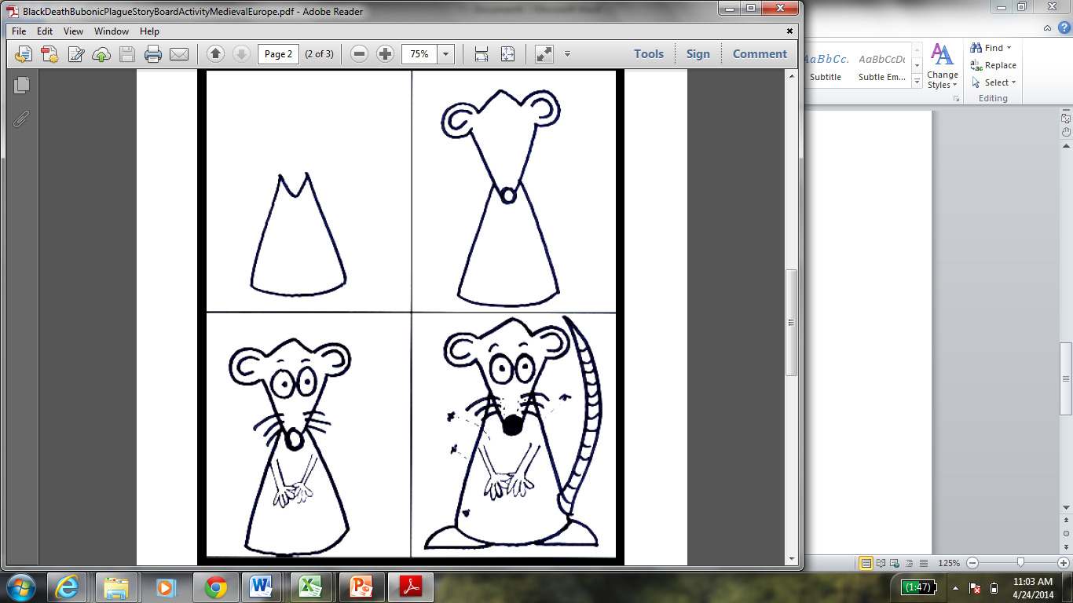

Spread of the Plague in Europe

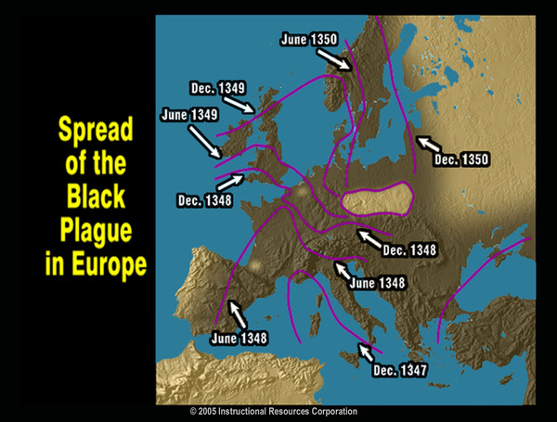

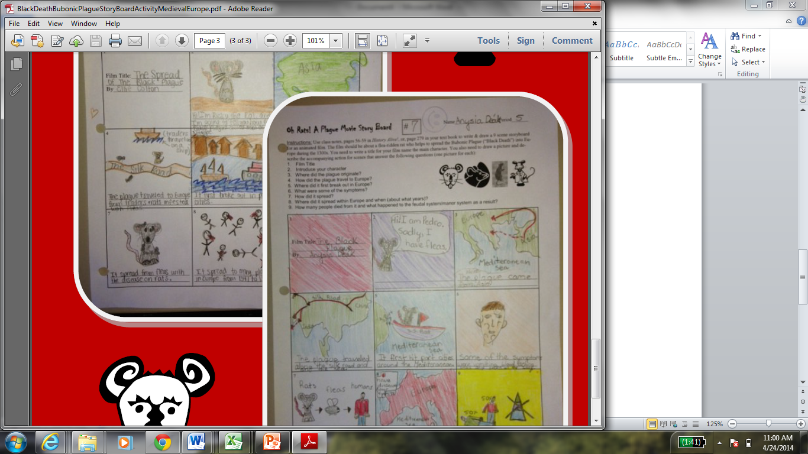

Student Examples